|  |
| --- |
|  |
| Spring Breaks ‘R’ Us  Business Requirements Document |
| |  |  |  | | --- | --- | --- | | Shuning Kruse | 9/3/19 | IT Analysis & Design | |

|  |  |  |  |
| --- | --- | --- | --- |
| Version | Date | Name | Description of Change |
| 1.0 | 08/26/2019 | Shuning Kruse | Initial Draft |
| 1.1 | 09/02/2019 | ShuningKruse | Stakeholders and Requirement |
| 1.2 | 09/09/2019 | Shuning Kruse | Event Decomposition and Use Case |
| 1.3 | 09/14/2019 | Shuning Kruse |  |
| 1.4 | 09/22/2019 | Shuning Kruse | Adding use case modelling |
| 1.5 | 09/29/2019 | Shuning Kruse | Integrity and security |
| 1.6 | 10/05/2019 | Shuning Kruse | Defining the System Architecture |
| 1.7 | 10/12/2019 | Shuning Kruse | Dialogue and storyboard |
| 1.8 | 10/26/2019 | Shuning Kruse | Approaches to System Development |
| 1.9 | 11/02/2019 | Shuning Kruse | Project Planning and management |
| 2.0 | 11/08/2019 | Shuning Kruse | Object-Oriented Design |
| 2.1 | 11/15/2019 | Shuning Kruse | Object-Oriented Design & use case realization |

**Problem Description**

Online booking has already stabilized for SBRU company and it has been a big part of business source. The students can book the desired destinations with reasonable price and comfortable hotel via online booking. Sometimes, the students may have some unsatisfied experience or excellent experiences want to share after vacation, but there isn’t a platform for that. Since SBRU already has a plan to add the new feature social networking for the students, it may help to solve this problem.

**System Capabilities**

The new system should be capable of:

* Students can create an account on this platform with their personal information
* Colleting the feedback from students
* Store complains from students to discussion board
* Providing Q&A platform for new and old customers (Students)
* Providing students to share real-time communicate with each other
* Possibility to upload pictures of hotel rooms and vacation destination.

**Business Benefits**

It is anticipated that the implantation of this new system will provide the following business benefits to SBRU:

* Helping SBRU to gather the first-time feedback from students, and it can help the company understand the needs of students.
* SBRU can enhance the system or service immediately after get information from discussion board
* Attracting new students to book the vacations with SBRU because the real-time communication board can help students immediately get the information, they need
* Maintain relationship with old students for future business or references
* Establish trustworthy impression for future potential students for using the real-time discussion and using updated pictures and immediate action for students feedbacks.

Initially the stakeholders need to be identified to define which parties need to be involved.

|  |  |  |
| --- | --- | --- |
| Stakeholder | Interest | Dimensions |
| Board of directors | 1. Make decision to invest project 2. Archive targets 3. Increase profits | Internal Executive |
| Partner organizations (Hotels) | 1. Access SBRU’s booking information 2. Damage report 3. Share prices and availabilities | External Operational |
| Customers | 1. Find perfect destination for Spring break 2. Easy access to communicate with hotels and spring breakers | External Operational |

After the stakeholders are set, the next will present functional requirements to reflect their interests.

**Functional Requirements**

* Payments Transections
* Accounting Interface
* Media Communication
* Hotel Login Access
* Customers Login Access
* Hotel Complain Management
* Customers Complain Management
* Financial Report
* Booking System
* News Letter Subscription

The new system will provide the functional requirement. For the users of the system it must be efficient to execute those functions. This will be described in the usability functions.

**Usability Requirements**

* iOS, Android, and Google App should be available as interface to the system
* A website should also be available as interface to the system
* Hotels should have a different view then customers when they login

Once the main functionalities and the usability are defined the requirements to performance and reliability must be defined to guarantee that the defined functions can be executed.

**Reliability and Performance Requirements**

* The system must be online and accessible 24/7 as customers and hotels has to login when necessary
* Only hotels with stable internet access can participate
* Hotels need to have an IT department to be able to do maintenance
* The software needs to be developed with most recent service patches to guarantee that it doesn’t crash on the phones or server
* The hotels need to have at least one state of the art computer to access to the system to guarantee that everything can process properly

The system does not only need to run efficiently. It also must make sure that the security concerns of the stakeholders are taken care of.

**Security Requirements**

* Financial transactions, passwords & bookings must be submitted encrypted to guarantee that no other party can read those information
* When one registers one must click on a confirm email to guarantee that the person owns the email account
* Passwords should be updated every three months and must be complex

There are many ways & techniques to collect information about requirements. For example, distribute and collect questionnaires, review inputs, outputs and procedures, observe and document business processes, research vendor solutions or collect active user comments and suggestions. In this case a questionnaire will be used to ask the stakeholders about the requirements.

**Sample questions are:**

* To the hotels: Do you want to add promotion functions?
* To customers: Would it be interesting for you to be able to refer to friends to redeem free stays in the hotels?
* To board of directors: Would you be willing to invest money (like free stays) to attract new customers when they first open the account?
* To the hotels: How fast could you react to customer complaints?
* To the customer: Would you come back to a hotel where you filed a complain but the hotel did react and fixed the problem?
* To the IT Department: How often would you like to update the system?

|  |  |  |  |
| --- | --- | --- | --- |
| SBRU Event Decomposition | | | |
| Users/Actors | **Type of Event** | **Use Case** | **Brief Description** |
| A student/group of students | External Event | Looking for break vacation | Students look for a place  to have break vacation |
| A student/group of students | External Event | Update and change information | Students update or change number of members or size of bedroom |
| System/accounting  /Management | Temporal Event | Sending out final payment notice | One month before the vacation sending out the final bill notice |
| A student/group of students | External Event | Cancel the booking or pay for the bill | Students either cancel the booking of hotel or pay the final bills |
| A student/group of students | External Event | Look up the booking status and resort info | Students look up their booking status and resort information |
| A student/group of students | Temporal Event | Check in and check out | Students Check in the resort and check out the resort |

**Use Case Diagram**

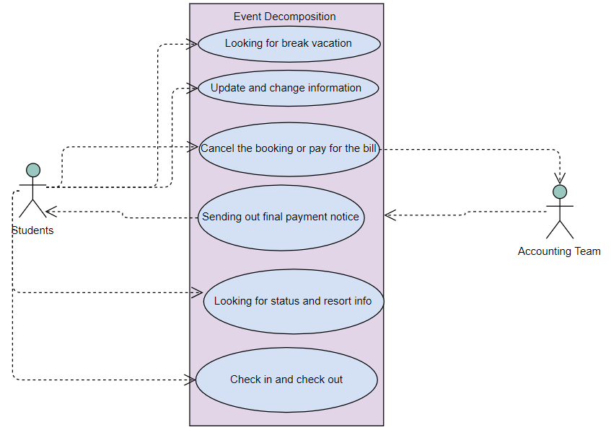

|  |  |  |  |
| --- | --- | --- | --- |
| SBRU Social Networking Subsystem | | | |
| Users/Actors | **Type of Event** | **Use case** | **Brief Description** |
| Marketing | External Event | Add new promotion | Add new features in social networking |
| Marketing | External Event | Add memberships  feature | Add new feature that students can create account on social network |
| Marketing | External Event | Collecting feedback and complains | Add memberships  feature |
| Marketing | External Event | Providing Q&A platform | Providing general questions and answers for the customers |
| Marketing | External | Add experience sharing feature | Add new feature that students sharing experience information on the social networking |

**Use Case Diagram**

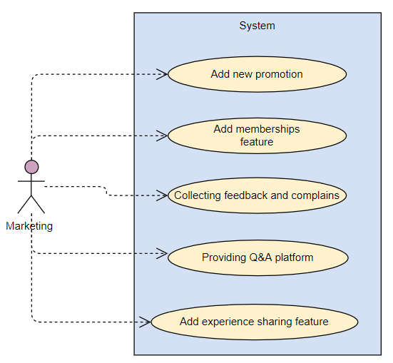

**Domain** **Classes**

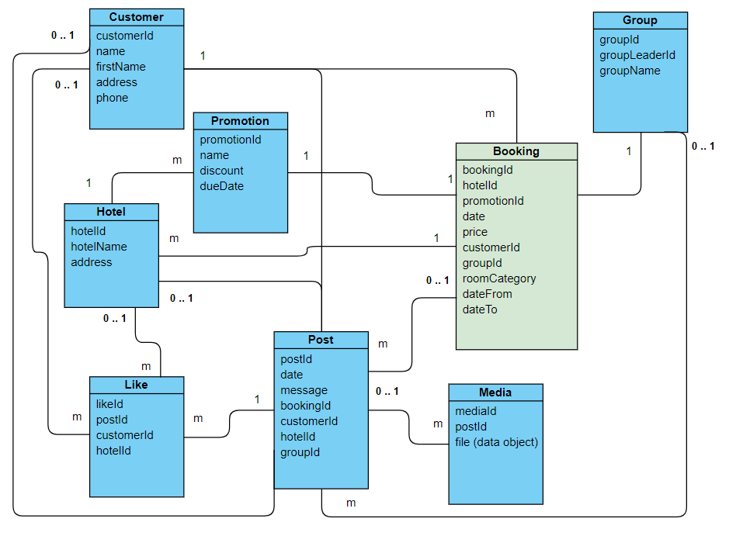

The necessary Domain Classes and their attributes and relationships are mostly based on the **booking**. Each customer can book multiple stays, each stay refers to one hotel, up to one promotion, a booking date, a price, a conditional group if it’s a group travel, a room Category and a from and to date. Each **customer** can also **post** or **like** in social media. Each post can contain multiple **media** files. A customer can create a **group** and be the leader of the group. Each **hotel** can also post or like social media content and create **promotions**.

**Chapter 5. Use Case Modeling**

In the last chapter we identified domain classes with their attributes and if and how they are technically connected. The next step will be to define use cases technically and show how those use cases affect the so far identified classes.

One use case is to add a new resort. The following diagram will describe this as fully developed use case.

|  |  |
| --- | --- |
| Use case name | Add a resort |
| Scenario | A resort will be added to the list of participating resorts. |
| Triggering Event | SBRU & the resort negotiate the conditions of the partnership. |
| Brief description | An employee on resort site has to enter all necessary resort data, after receiving an invite email. It is not possible to just create a resort account without invitation. |
| Actors | Resort, SBRU |
| Related use cases | Related to add new vacation offers package. It is not possible to create a vacation without a hosting resort.  Also related to book a reservation as this requires an existing resort |
| Stakeholders | Management (Decision), partner management (send invite mail), Resort |
| Preconditions | Partnership conditions between resort and SBRU must be negotiated  Invite email must be sent out from partner management |
| Post conditions | Resort must be created, including all mandatory data |
| Flow of activities | |  |  | | --- | --- | | Actor | System | | 1. Partner management decides that resort is qualified to participate. One employee enters the email address of the hotel’s counterpart to the partner manager | * 1. System creates blank resort, only containing the email address   2. Invite email will be send out | | 1. The resort will let somebody enter the data | * 1. Address information will be stored   2. Payment information will be stored | | 1. Resort receives message that it was successfully created | * 1. System sends email about successful created resort   Or | | 1. Resort couldn’t be created | * 1. System cannot create resort because of missing information. | |
| Exception conditions | Resort data are incomplete |

This use case is described as an SSD in the following diagram. Actors are partner manager and representative of the resort. Both are interacting with the same system.

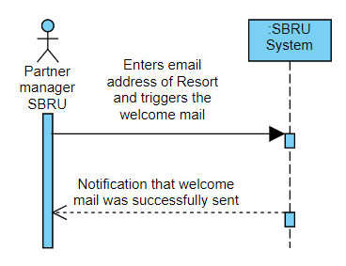

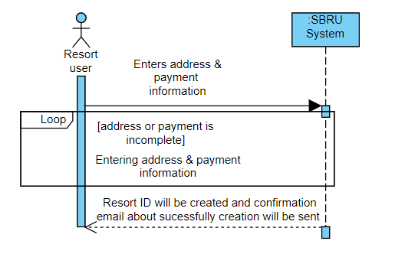

A fully developed use case will hereby also be shown for the use case: book a reservation.

|  |  |
| --- | --- |
| Use case name | Book a reservation |
| Scenario | A customer tries to book a reservation |
| Triggering Event | Desire to book a vacation |
| Brief description | The customer checks availability for a room and conditions. If the feedback satisfies the expectations of the customer, he will book the reservation and will receive a confirmation if the process worked out successfully |
| Actors | Customer, Resort |
| Related use cases | Add a resort |
| Stakeholders | SBRU (Hosting the system and making money on commission base), the resort (service provider), the customer |
| Preconditions | Resort must exist  Offer must exist (e.g. package of particular rooms) |
| Post conditions | Reservation must be made  Money must be transferred  Confirmations need to be sent |
| Flow of activities | |  |  | | --- | --- | | Actor | System | | 1. Customer checks offer of participating resort | * 1. System shows master data of resort (like address)   2. System shows offers (room types) | | 1. Customer checks availability based on required beds and date | * 1. System checks if there is enough room at desired date available | | 1. Customer checks price | 3.1 System shows price | | 1. Customer accepts offer | * 1. Customer confirms the offer per click   2. Customer can add a promo code   3. Customer has to create customer account to book or login to account   4. Customer makes payment   5. System sends money from payment input to payment output via defined payment method   6. Reservation will be booked | | 1. Or Customer rejects offer | 5.1 Customer just rejects the offer. No reservation will be created | | 1. Customer receives status | 6.1 System sends status email about successful booking or shows popup if the hotel does not have the desired availability | |
| Exception conditions | Room not available at desired time  Number of beds doesn’t satisfy  Customer doesn’t accept conditions |

The SSD for this use case can be found in the following diagram.

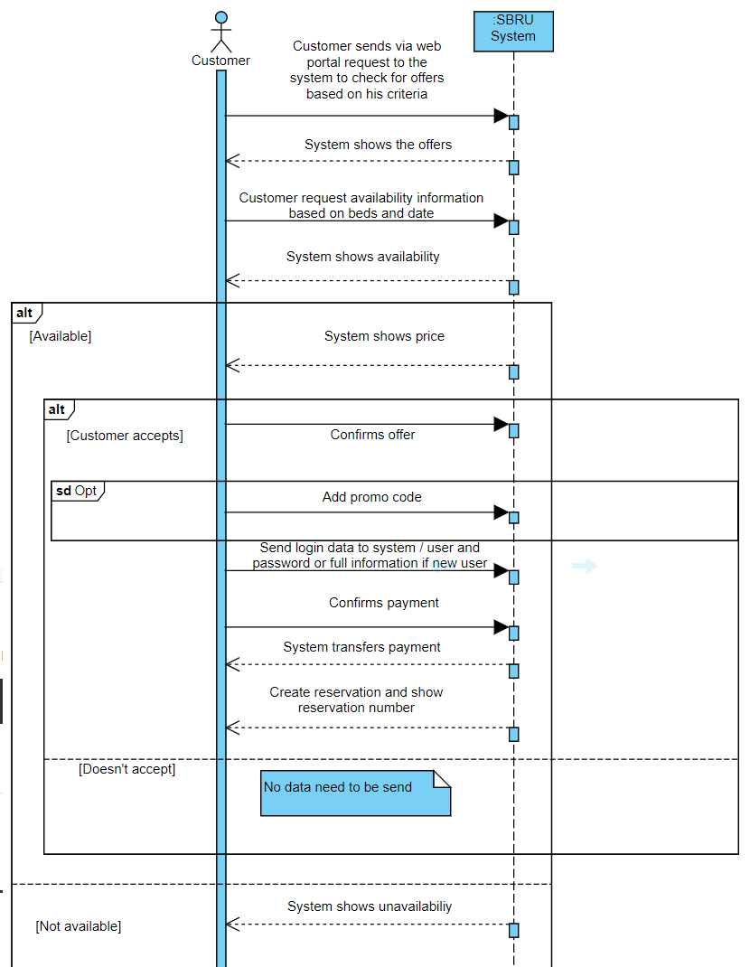

The activity flow can be described in an activity diagram. The use case to enter a resort will be shown in the following activity diagram:

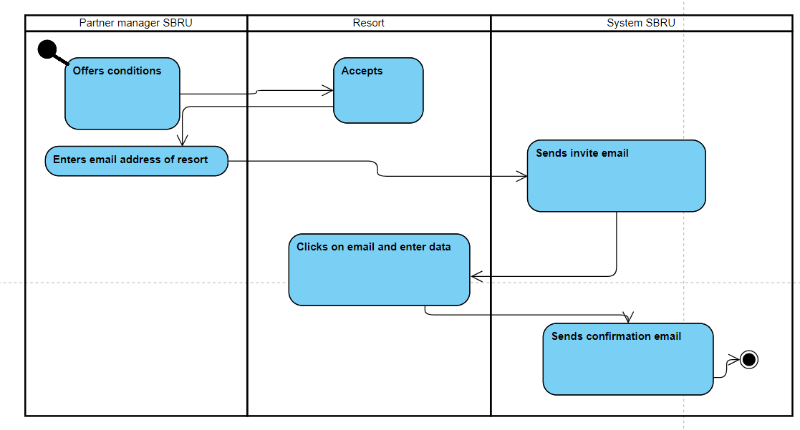

This diagram includes the involved actors and their actions.

To highlight which actor has to create (C), read or report (R), update (U) or delete (D) data/attributes it is easy to use a CRUD diagram. The following diagram shall show that information for the so far identified use cases and the domain model.

|  |  |  |  |  |  |  |
| --- | --- | --- | --- | --- | --- | --- |
|  | Resort | Customer | SBRU partner manager | SBRU Marketing | SBRU  Management | Accounting |
| Create resort | CUD | R | CUD | R | R |  |
| Create reservation | RUD | CD |  |  | R |  |
| Add new promotion | CUD | R | R | R | R |  |
| Add memberships  feature |  | CUD |  | R | R |  |
| Collecting feedback and complains | CRUD | CRUD | R | R | R |  |
| Providing Q&A platform | RUD | RUD |  | RCD | R |  |
| Add experience sharing feature | CRUD | CRUD | R | R | R |  |
| Looking for break vacation |  | R |  |  |  |  |
| Update and change information | RU | RU |  | RU | R |  |
| Sending out final payment notice | R | R |  |  |  | R |
| Cancel the booking or pay for the bill | R | U |  |  |  |  |
| Look up the booking status and resort info | R | R |  |  |  |  |
| Check in and check out | U | C |  |  |  |  |

Mostly the customer and the resort can add content, create events, change things or cancel them. SBRU mostly gets notified.

**Chapter 6: Integrity and Security**

The most important subsystems for security control are Student booking, Accounting and finance, and Social networking. The Student booking module contains students’ personal information such as names, emails, and home address. Some information may be connected to the billing account and could hold information such as credit card details. Accounting and finance are obviously also sensitive because they are in charge with very private finance data from students and the SBRU. Because this subsystem holds the most principal details of students, it should well protect during the operational process. Social networking is a tool that can let students to have secure and private communication with each other. It should be very well protected for the sensitive messages that could be included, such as accounting information and personnel data.

Student booking and transaction data should be encrypted during the process, as previous explanation student booking holds students’ personnel info. Protective actions must be applied to data that is stored or transmitted, especially outside the organization’s own network, such as personal cell phones or personal PC. Data and files should be encrypted to be protected against theft. Information inside the organization must be protected too. For example, if one software is communicating with another software like the accounting system which is exchanging information with the booking system.

Not only should the data be encrypted. Access should always only be granted to those who have a registered and verified (per mail) account. Access is always limited to what a user must see to process the information. E.g. the customer does not need to see the hotels bills which are not related to his own account. The hotel must not see other bookings of the customer which are unrelated to the own hotel.

The integrity of the data should also be controlled. There should be some input controls like: Checking if addresses are valid according to standard formats, checking if credit card numbers and due date/security code match (this will be done with external API to financial institution such as Mastercard, Visa…). It must also be checked if information is complete: e.g. a booking must contain acceptance of offer, payment method, valid address information, number of persons, number of beds, full names and email addresses of each person. If the account transaction appeal that the amount of payment is different from it should be, the account must send the alert and must not process the action. The booking date must be in the future, if the booking date is earlier than the day that made reservation, it must act to stop the operation immediately.

There must be limitation for people who can access the data to print out the students’ information related documents and accounting data. The people who can have such access must be upper management and those whom in charge with the information.

The discard documents should have particular people to category the documents and in order to shredded it.

The security action and integrity will be applying to the smart phones as well. The explanation will display with the diagram.

**The next page will have Security and integrity control diagram**

* Internet is the connection for resort and customers
* Internal network is for SBRU

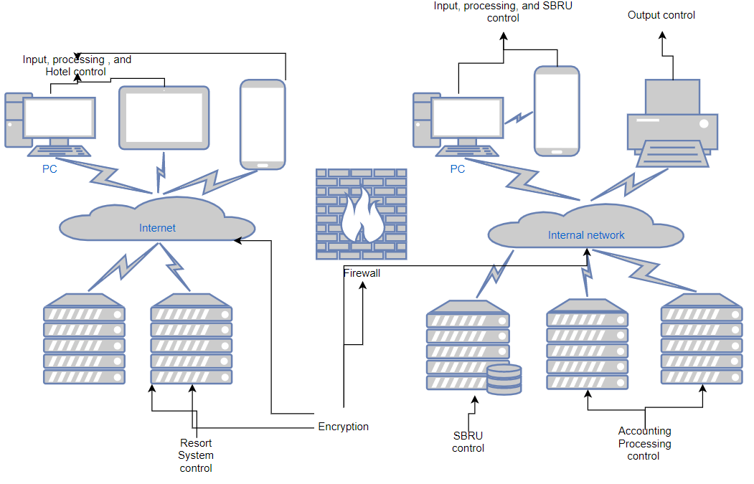

This diagram is to show the connect between internet and internal network. It demonstrates how the firewall to protect the connection between internet and internal network. Before the server received the data, it will be encrypted. After the messages arrived, data will be decrypted.

**Chapter 7 Defining the System Architecture**

A network diagram shows how locations and hardware components are interconnected with network devices and wiring. In SBRU company, there are four subsystems: Resort Relations, Student Booking, Accounting/Finance, and Social Networking. Between resort and SBRU servers, there is firewall to protect the network. The students can use any kind of devices (Cellphone can directly connect with internet) to interconnect with the servers from SBRU. The following diagram to show the interconnection relationships:

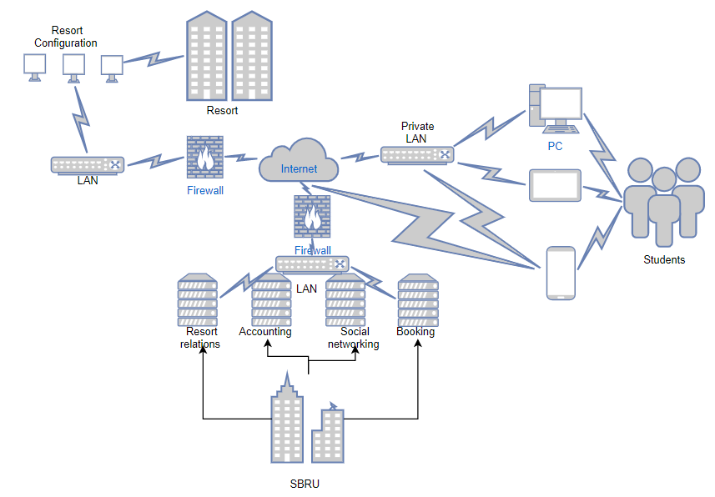

Different sizes business suitable with different servers, as a small business like SBRU, need servers that scale to it needs. You should not overpay for resources that you do not use though. That being said: If SBRU is hosting all the hard- and software this will mean high costs for the hard- and software. The software cost are not only the license costs but also the ongoing maintenance cost which means SBRU either have to hire IT people or have to outsource them. On the other hand, will SBRU be in charge of everything and have not only full ownership but also owns the knowledge. If the hardware is outsourced to Amazon or Google there are fewer initial costs for hardware, however there will be a monthly fee which means usually higher total costs, the longer the system will run. If the business plan is a risk the money loss is smaller if everything was hosted as if all hardware had to be purchased. The software site is different. The question about the software site is almost the same than if the server would be host by SBRU. Own IT people mean permanent monthly costs (salary) but guarantee the knowledge stays with SBRU vs. the knowledge would be transferred to Google if their architects would be hired on an hourly base. Benefit is that it is easier to stop using external software developers vs. firing / training own people.

Assuming if that cost of external hosting is equivalent to staffing, training, own hardware. Under these circumstances it is not worth it to choose the external service provider, if the knowledge shall be protected and shall be part of the company’s values. However, if everything is well documented and the knowledge can be shared without doubt to a service provider in that case it might be worth it to use the external hard- and software. The reason is that a hosting company like amazon will make sure to keep the systems always up to date, their employees will be permanently training according to new technologies and so on. For that reason, in that case it is better to chose external hosting.

If the cost for external hosting would be 50% higher than hosting at SBRU and training own people, it is probably not worth it to outsource. On the one hand the customer would always be up to date with trainings and updates, and the risk would be on the external hosts site. However, for that massive amount of money which would be saves SBRU can train own people with new technologies and can implement their own state of the art security systems.

Targeting also Europe and South Africa doesn’t affect the answer. Both markets require expertise and potential changes in the software. However, those changes are on SBRUs software site and don’t affect the physical server. Even if external experts would be hired those would not necessarily be software developer but business consultants who explain the risks and challenges of the new markets. Additional continents do not require new physical servers as the internet operates world wide in the same way.

**Chapter 8 Designing the User Interface**

The concerned arise from the resorts and parents of students off or on-site safety. Therefore, the system needs to develop another new app that can send the alert to the resort security patrol when abnormal situation happens. According to the user case, the customers can create an account and login the account with basic information that signed up.

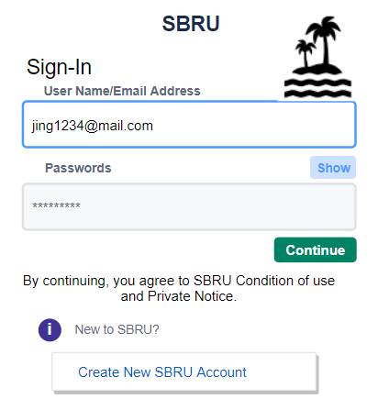

After the user sign up, the system will send the user’s information to the security system which is the safety application from the resort security patrol. The sent information are: GPS data, user ID to connect to the customer name, the booked resort stay and the time for each event.

Before the development can take place, it is necessary to cover the possible use cases. One way to identify those is to create user dialogues and story boards. The following user dialogue is based on a security scenario. After the dialogue is created the next step is to create the storyboard.

Security dialogue:

System: Traveler with ID 54321 is alone in pool area. Security incident created with ID 123456. It is 1am (1 hour after the pool closes). Do further actions?

User: Yes, show me options

System: We can turn on the light at the pool, check the security camera, start the alarm siren, send a security staff, send a text to the customer

User: Turn on the light

System: Lights are on, now. Further action needed?

User: Show the camera

System: Picture is provided. Further action?

User: Yes send a text to the customer: ‘please leave the pool area as it is after midnight’

System: Text send. Further action?

User: I waited 5 minutes, nothing happened. Please send a message to the staff member which is closest

System: Done. After the staff member arrived the customer started to walk back to its room

User: close incident 123456

The storyboard for this dialogue will be displayed.

Step 1

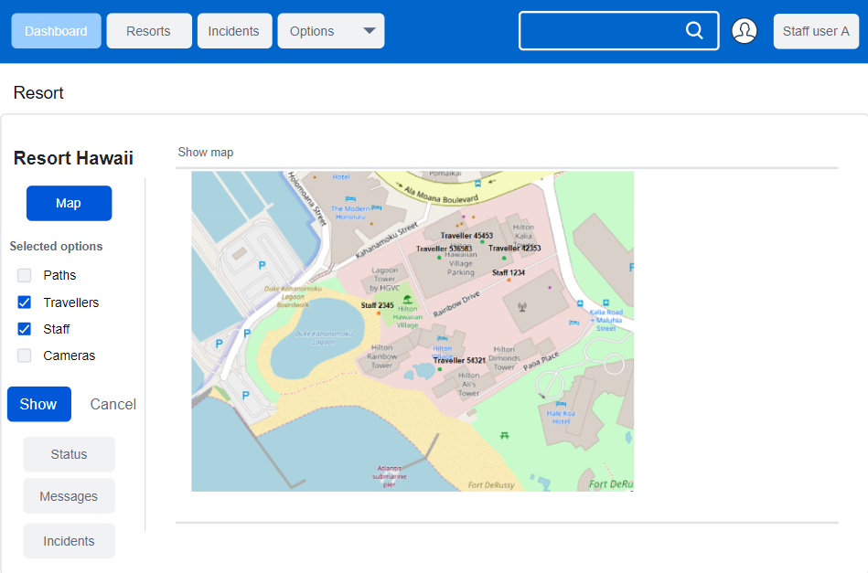

There is a main website which let the security people login and select the resorts which they can access, the incidents and the options. This sample shows the resort view. The option map is selected which allows the user to display paths, cameras, travelers and staff.

A status button allows to display further information about either staff or travelers. Messages allows the staff to communicate with staff, parents and travelers. The incident menu allows the staff member to manage security incidents. Those incidents contain the exchanged messages, GPS and time data and the status of each security issue.

The staff members can be shown which is necessary to identify which staff member is close to the location of an incident to do actions. It is possible to click on traveler or staff dots on the map and interact with them while sending messages to their phone. Cameras can also be accessed.

The event of the dialogue above will look like this:

Step 2 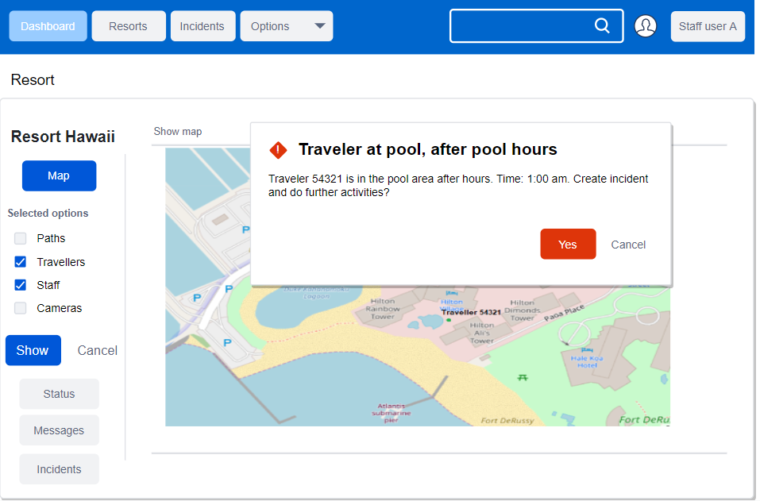

Step 3

After selecting yes.

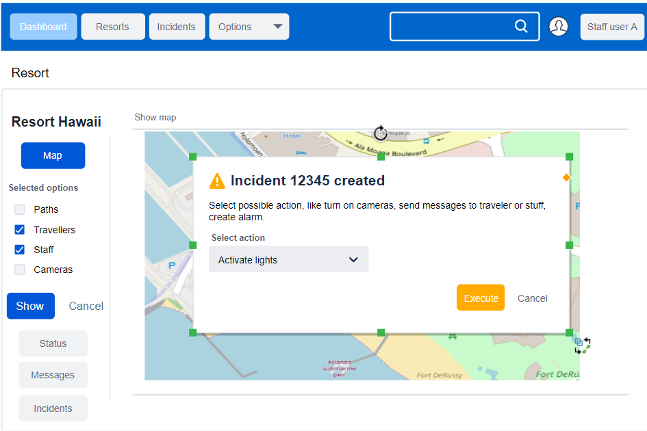

Step 3

Customer could choose between (send message to traveler, send message to staff, turn on light, check camera, Activate alarm siren, close incident). Customer selected turn on lights.

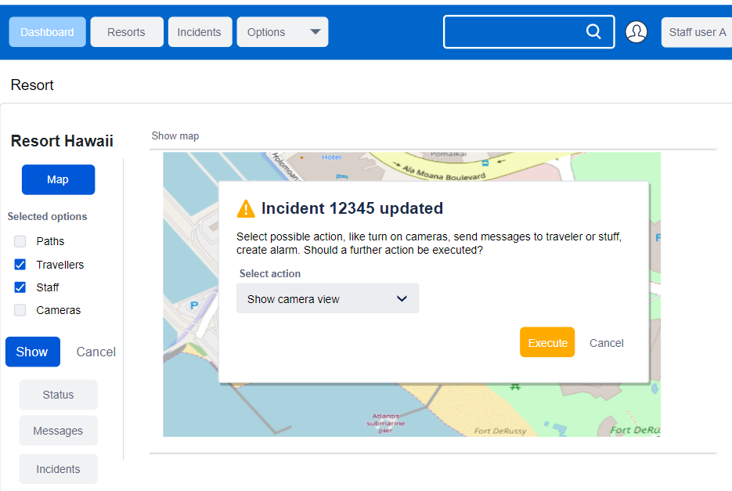

Step 4

User checks camera

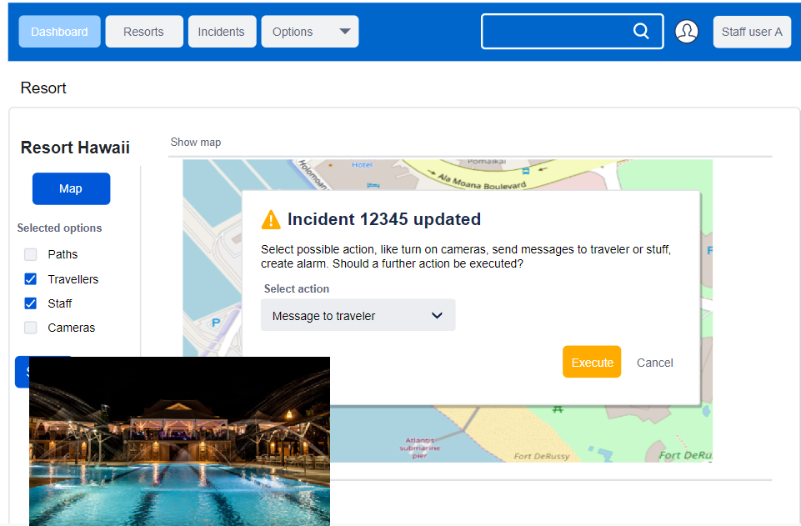

Step 5

User decides to send a message to the traveler

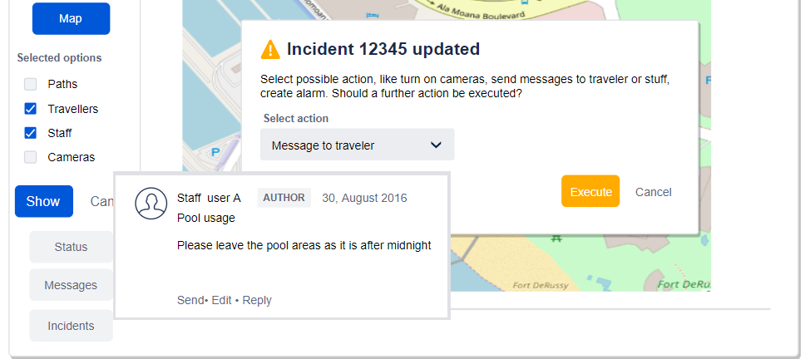

Step 6

Nothing happened. User decides to send a message to the staff

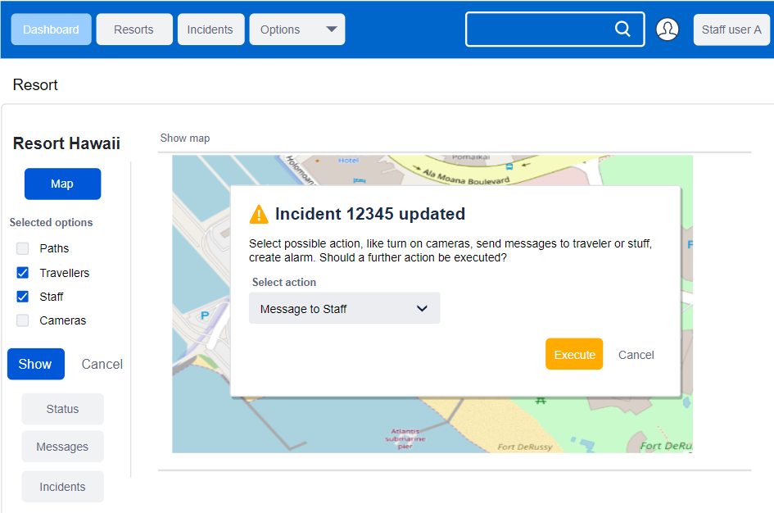

Step 7

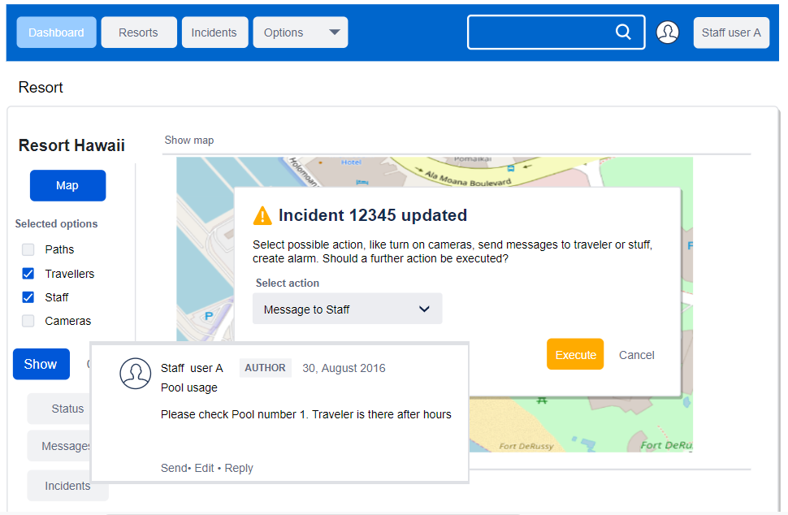

Step 8

Final step. Incident can be closed.

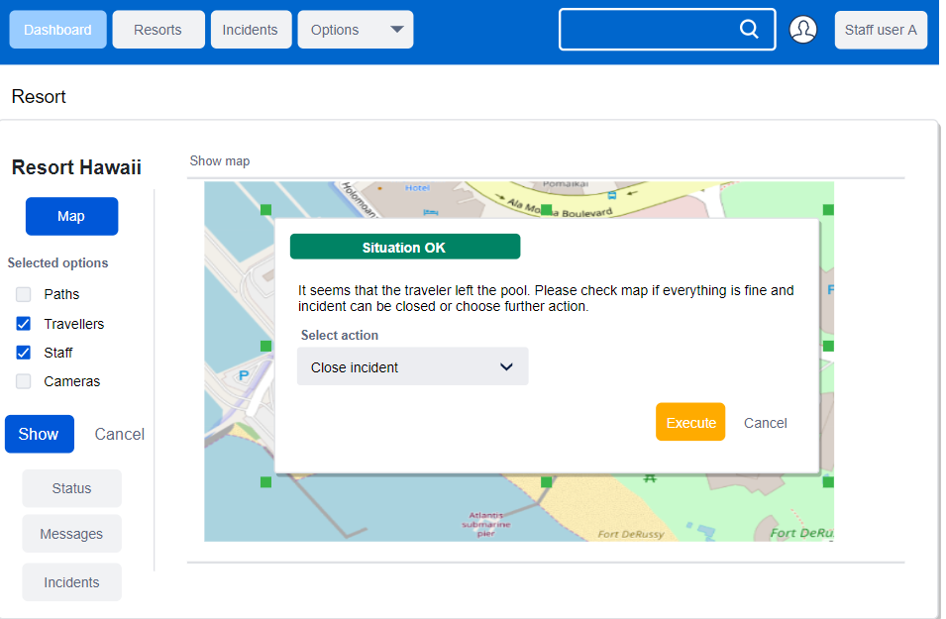

**Chapter 10 Approaches to System Development**

Based on Social networking domain class, there are classes will be connected to the subsystems more than one time. Let’s make a table to clarify the relations between them:

Social Networking domain class:



|  |  |  |  |  |
| --- | --- | --- | --- | --- |
| Domain class | Resort relations | Student booking | Accounting/Finance | Social networking |
| Customer | **x** |  |  | **x** |
| Hotel | **x** |  |  | **x** |
| Promotion | **x** | **x** |  | **x** |
| Like |  |  |  | **x** |
| Post |  |  |  | **x** |
| Booking | **x** | **x** | **x** | **x** |
| Media |  |  |  | **x** |
| Group |  | **x** |  | **x** |
| Maintenance request | **x** | **x** |  |  |
| Fees Transaction | **x** | **x** | **x** |  |
| Address | **x** | **x** | **x** |  |
| Contact info | **x** | **x** | **x** |  |
| Security | **x** | **x** |  |  |
| Credit/debit info | **x** | **x** | **x** |  |
| Student Feedback | **x** |  |  | **x** |
|  |  |  |  |  |

Each customer can make multiple bookings but only one address and one contact information.

Each hotel can make multiple bookings but one booking one transaction needed.

The customer can have many credit/debits accounts saved and can make many transactions

Hotel and customer can have many security events.

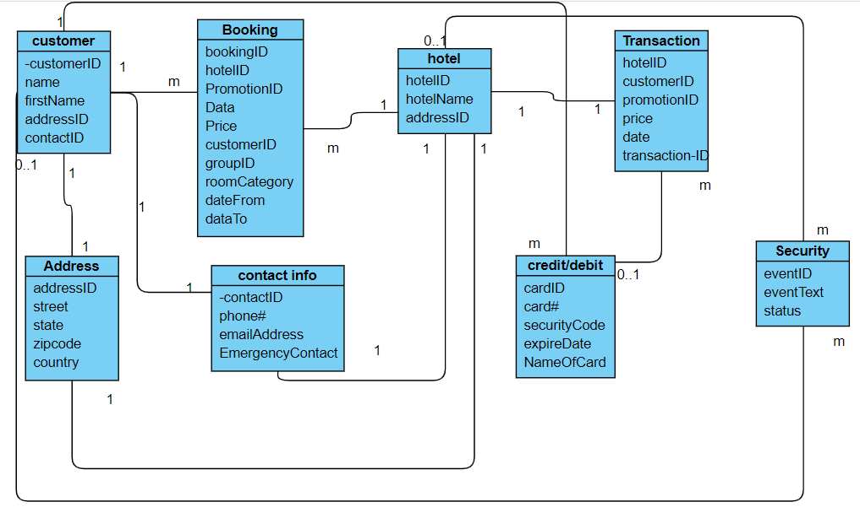

In this domain class, illustrate how the relationships connected with each classes or attributes. But what about the detailed activities that occur within each class or attribute?

Using the classes or attributes that involved in each iteration to explain the relationship and understanding for the relation modeling.

* Customer-customerID
* Booking-bookingID
* Contact info-contactID
* Address-adressID

For each iteration, the project team must understand the main connecting subject(customers) , define the requirement that portion of the resort team must satisfy(Booking), to connect the customers and resort for that portion of the system that satisfies the requirements(contact information), send bills and confirm transaction and booking information that makes portion of the system(Address).

All eight domain classes or attributes are employed throughout the lifetime of project but to different degrees.

As a system development methodology, the Unified Process must be tailored to the development team and the specific project. Choices must be made about which deliverables to produce and the level of formality, or ceremony, to be used.

The people involved in system development whether as team members, users, or other stakeholders all need to accept the priorities for a project to be truly agile.

Agile development gives bigger space for the unpredictable flexibilities. Developer need to accept a certain amount of chaos and mix that with other Agile modeling and development techniques that help to provide order and structure to this project.

Customer booking a hotel room maybe have a period time frame. In this time frame will have so many unpredictable situations may happen, so for inputting agile development techniques in this study case will create a flexibility for the resort and customers decisions.

**Chapter 11 Project Planning and Project management**

According to the growing of SBRU company, the structure of company become more mature. With couple months effort, one subsystem become four subsystems. Today, we are going to design another three subsystems functional requirements and user cases.

This the first subsystem we design from beginning of the company established:

**Social Networking Subsystem Functional Requirements:**

* Media Communication
* Hotel Login Access
* Customers Login Access
* Hotel Complain Management
* Customers Complain Management
* News Letter Subscription
* Promotion/Benefit

|  |  |  |  |
| --- | --- | --- | --- |
| SBRU Social Networking Subsystem | | | |
| Users/Actors | **Type of Event** | **Use case** | **Brief Description** |
| Marketing | External Event | Add new promotion | Add new features in social networking |
| Marketing | External Event | Add memberships  feature | Add new feature that students can create account on social network |
| Marketing | External Event | Collecting feedback and complains | Add memberships  feature |
| Marketing | External Event | Providing Q&A platform | Providing general questions and answers for the customers |
| Marketing | External | Add experience sharing feature | Add new feature that students sharing experience information on the social networking |
|  |  |  |  |

These are the other three subsystems that newly developed:

**Student Booking Subsystem Functional Requirements:**

* Create Student account
* Add Student account information
* Save Student booking information
* Save Student booking history
* Add Student credit/debits card information

|  |  |  |  |
| --- | --- | --- | --- |
| Student Booking Subsystem | | | |
| Users/Actors | Type of Event | Use case | Brief Description |
| Students | External Event | Create Student’s account | Create a account that able to log in with accounts name and password |
| Students | External Event | Add Student basic student information | Add student’s personal basic information such as name, address, and emergency contact information |
| Students | External Event | Save student booking information | After student booked a vacation, the system saves it for customer and resort or company to check. |
| Students | External Event | Save booking history | Saving booking history for records. Use for reference or participate promotions |
| Students | External Event | Add student credit/debits cards | Add payment information for payment transaction |

**Accounting and Finance Functional Requirements:**

* Fully access to payment account (Credit/debits cards accounts)
* Verify payment information during each transaction process
* Sending out payment and due day confirmation
* Sending out expired cards or updated new valid cards information
* Calculating company revenues

|  |  |  |  |
| --- | --- | --- | --- |
| Student Booking Subsystem | | | |
| Users/Actors | Type of Event | Use case | Brief Description |
| Accountings | Internal Event | Full access to payment account | Able to access payment account from students |
| Accountings | Internal Event | Verify payment transactions | Verify each transaction from payment according to the student user accounts |
| Accountings | External Event | Sending payment and due day confirmation | Sending out payment receipt and due day confirmations to students |
| Accountings | External Event | Sending updated valid cards to student | Sending notifications to students to update new valid credit/debits cards |
| Accountings | Internal Event | Calculating revenues | To calculating the revenues yearly |

**Resort Relations Functional Requirements:**

* Resort communication
* Resort maintenance update
* Resort promotions movement
* Resort update booking or cancellation information

|  |  |  |  |
| --- | --- | --- | --- |
| Student Booking Subsystem | | | |
| Users/Actors | Type of Event | Use case | Brief Description |
| Partner management | External Event | Resort communication | Maintaining good relationship with partners to gain better understanding for the collaboration |
| Partner management | External Event | Maintenance update | Collected feedback from students’ requirements and give back to resorts and follow up the updates |
| Partner management | External Event | Promotion movement | Follow up with resort for the newest promotions. Give back the information back to marking |
| Partner management | External Event | Update booking or cancellation information | To inform booking and cancellation information to resort and let them to have the newest information for the reservation or cancellation |

The most subsystems are related with each other to complete the functionalities however there is one subsystem can be worked alone which is student booking subsystem. The student booking subsystem can be created individually. It has own system to let students created an account to start establishing the first relation with company. It allows students to save the information based on their personal data. In business point of view, student booking is the major action to begin with business process to the next step. Without this procedure, the business cannot predicate how many customers will be attracting. In the same time, social networking will be the next import to be considered. The reason is the company through social networking to gain the experience of customers satisfaction. It can share the promotion to the customer in order to attract more customers. It is not just creating platform to let customers share or obtain the experience and information. It also functions as a customer service to fix or answer the question or problem from customers point of view. It is straight forward way to gain the user experience to enhance the functionality of system to the company.

**Chapter 12 Object-Oriented Design: Fundamentals**

The student method will start the booking process and booking method continue the procedure to the next step.

After booking method got the customer info and price of the hotel cost and hotel info, the SBRU accounting dep will according to customer’s info to prepare credit/debits cards for the transaction method.

If the credit/debits card account info is valid and the customer’s info is correct, the transaction method will process the payment. In the transaction method, there is cancel payment valuable. The reason for this value is for when the customer cancels the reservation.

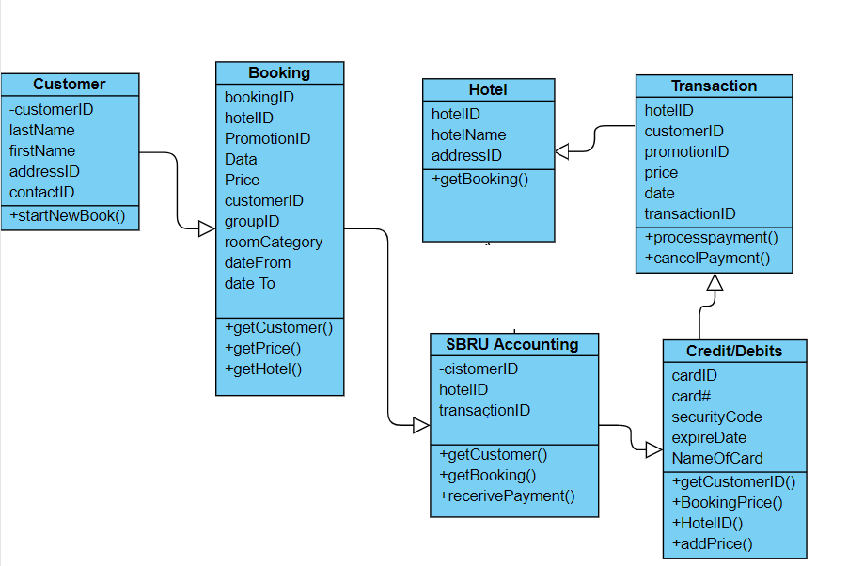

The following paragraph describes CRC cards for various classes which contain the name of the class on top, the responsibilities on the left, the collaborating classes on the right and the attributes on the back site.

The customer class e.g is responsible to hold the login information of the customer. The customer can also search for resorts and initiate booking requests/available stays. For that reason the class need to be connected with booking, credit and debit (for payments) and the hotel class

|  |  |
| --- | --- |
| **Customer** | |
| Login in account  Start to book resort  Make payment | Booking  Credit/Debit  Hotel |

|  |
| --- |
| customerID  cardID  fName  lName  address information |

The booking class is the interface between customer, hotel and SBRU. The class gets information from the customer about booking requests and forwards them to the hotels. Its basically a broker.

|  |  |
| --- | --- |
| **Booking** | |
| Receive customer booking info  Obtain hotel availability & price  Send booking confirmation to hotel and customer | SBRU Accounting  Hotel  Customer |

|  |
| --- |
| CustomerID  BookingID  HotelID  Price |

The Hotel class is interacting with the booking class but also with SBRU accounting because the payment. The customer need to contact the hotel to check in & check out

|  |  |
| --- | --- |
| **Hotel** | |
| Receive booking info  Get customerID  CheckIn  CheckOut | SBRU Accounting  Booking |

|  |
| --- |
| BookingID  customerID  transactionID |

The SBRU Accounting class books the payments between customer, hotel and SBRU. Money flow will be handled with an interaction with the transaction class

|  |  |
| --- | --- |
| **SBRU Accounting** | |
| Received the payment info from booking  Payment from customer to hotel  Payment from hotel to SBRU  connect to credit/debits card according to customerID via Transaction class | Booking  Credit/debits  Hotel  Customer |

|  |
| --- |
| BookingID  Credit/Debits  Customer  Hotel  TransactionID |

Depending if it’s the card of the customer or hotel the corresponding number will be stored.

|  |  |
| --- | --- |
| **Transaction** | |
| Receive credit/debits info  Get Money amount from booking  Get payer info from booking  Get payee info from booking  Triggers transaction | Credit/debits  Booking  SBRU Accounting |

|  |
| --- |
| CustomerID  CardID  HotelID  Amount  Paymentdate |

The primary driver of everything is the booking class as it merges customer, hotel, SBRU. Without a booking there is no major connection between all the other classes.

The following document shows the class diagram, updated with the CRC cards content

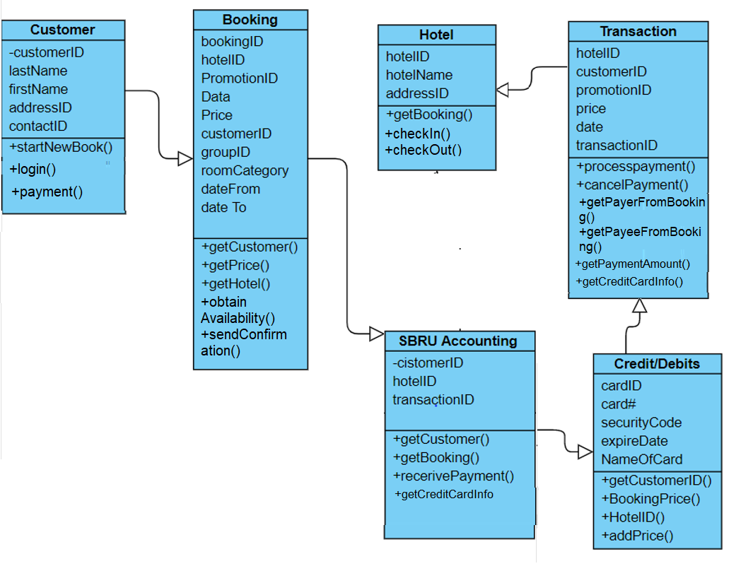

The diagram is mostly extended with interaction classes to get information from classes which contain necessary information. The link is mostly the ID.

**Chapter 13 Object-Oriented Design: Use Case Realizations**

Booking subsystem DCD

In the previous chapter, I have demonstrated the booking domain class, but this version declares the attributes type to Clearfield the valuables in the class. As you can see, the updated first-cut DCD enhanced the version of previous one.

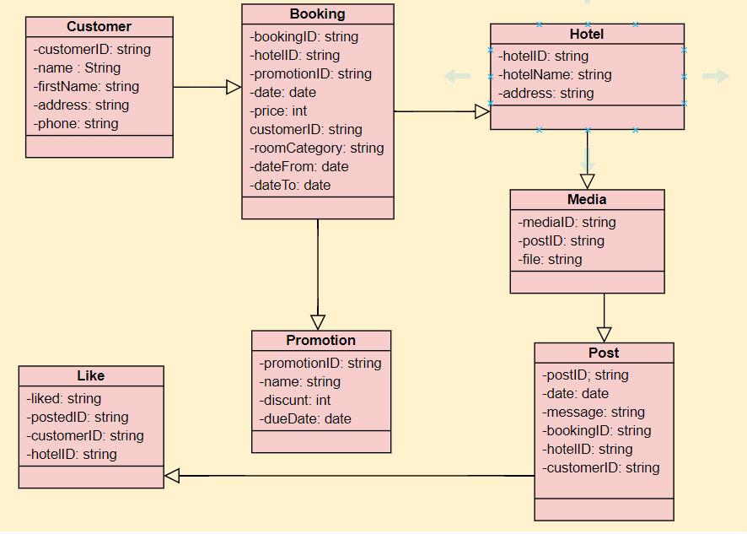

The communication diagram can easily explain the relationship between each class and process procedures. The resort sent out the request to the customer to gain the customer’s booking details. The customer needs to provide customerID, bookingID, and hotelID in order to booking the hotel then send the information back to the resort. The resort through the info to receive the booking information then make a reservation for the customer. 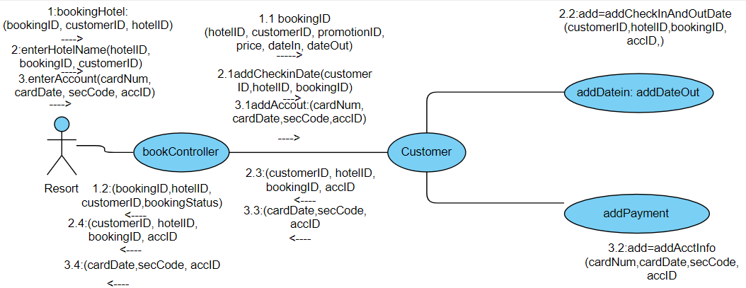

The customer checks availability for a room and conditions. If the feedback satisfies the expectations of the customer, he will book the reservation and will receive a confirmation if the process worked out successfully



The multilayer sequence diagram is to separate the responsibilities for each valuables and attributes behind the design of the data access layer. This diagram has three steps of layers. The first one is the customer start to book a hotel for the spring break. The second layer is the loop of the process. The last one is where the data.

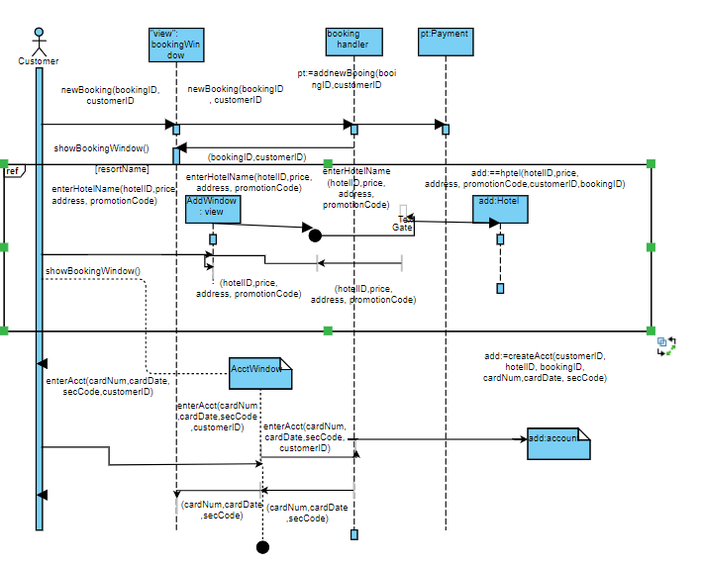

This diagram is according to the data access view layer.

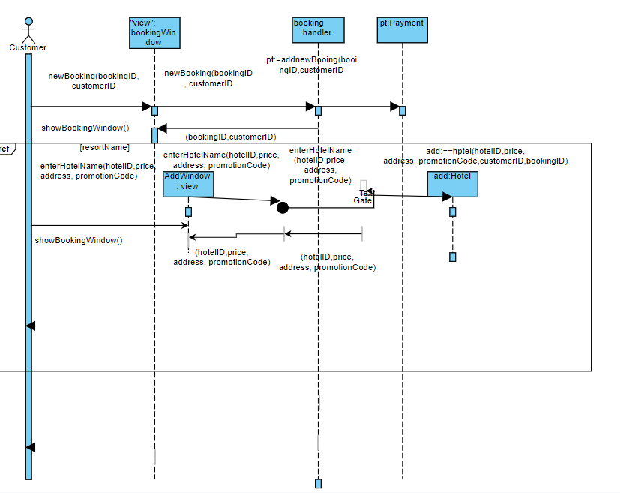

Finally, the classic three layers designed. This three-layer diagram is a excellent design style in the IT industry. Let’s starting with button one, database layer; which is the foundation of this diagram. Usually programmer designs a program will start to create a database, it is to prepare for the domain layer which is the actual programming starts. The domain layer is developer user programming logic and syntax to design the functionality of the entire program. Last is the user view, which is the interface that only shows to the user and lets users make a reservation and create an account or make payments. 